City of Corpus Christi Performance Evaluations
FY 2023 Procedural Guidelines- For Supervisors
Introduction

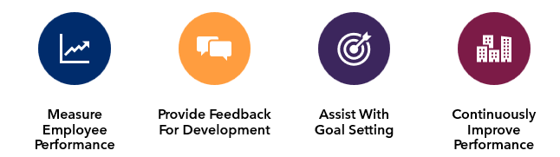
The City of Corpus Christi’s Employee Performance Management Process is designed to:

To encourage exceptional employee performance it is important for supervisors to:
- Lead by example. Meet with staff regularly throughout the annual evaluation cycle to:
  - Establish expectations
  - Identify and provide training and support
  - Evaluate progress
  - Document results
- Ensure that annual ratings are well documented, consistent throughout the organization and submitted in a timely manner

October 1, 2022-September 30, 2023
Key Dates
- Observation Period
September 25- October 2
- Employees (200/300 level) may complete self assessment form
- Due to Supervisor no later than October 2
September 29
- Performance Evaluation Spreadsheet sent to all department Directors
October 2
- Supervisors can begin completing evaluations
October 30
- Performance Evaluations Spreadsheet Submission Deadline
  - Department Head submits to HR department
November 1-14
- Performance Evaluations Spreadsheet will be reviewed by ELT Team
November 15
- Performance Evaluations Spreadsheet will be returned to department with edits
- Supervisors may begin meeting with employees for evaluation
December 15
- All performance evaluations with appropriate signatures due to HR
- Form 12 due to HR
January 1
- New pay rate takes effect (Will be reflective on January 12 check)
Training Dates
September 6
- 2PM, Live- City Hall
September 13- Dir/ Asst Dir/Dept Heads
- 10AM, Live- City Hall
September 19
- 2PM, Online
September 21- Dir/ Asst Dir/Dept Heads
- 3PM, Online
September 26
- 10AM, Online
September 28
- 9AM, Live- City Hall

Performance Evaluation Forms
100 Pay Plan Evaluation Form
- In Person Form
200 Pay Plan Non-Supervisor Evaluation Form
200 Pay Plan Supervisor Evaluation Form
300 Pay Plan Evaluation Form
Employee Self Assessment Form (optional)
Performance Evaluation Spreadsheet- For Department Heads Only
Rating Scale
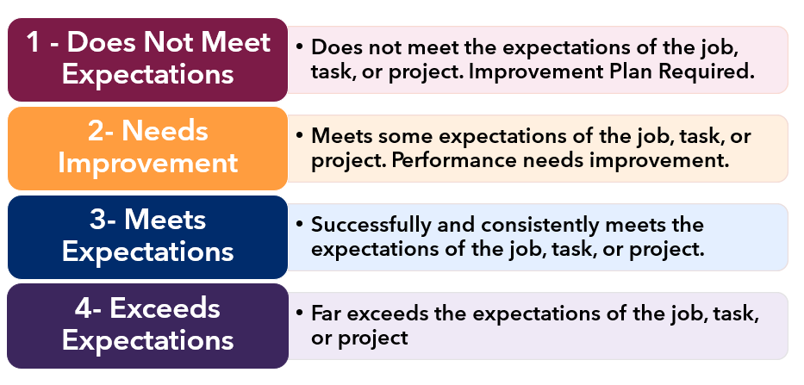
Each category or question will have a ranking of 1-4. These will be entered as whole numbers only. In addition to each category, there is an overall evaluation score that will be automatically calculated. This will also be a whole number i.e overall score of 3- not 3.5. The formula on the evaluation is set to round up/down to the nearest whole number.
Remember this is annual review. The review period is for one year only- not the tenure or entire career of an employee. This rating should strictly be based on employee performance from October 1, 2022 -September 30, 2023. Their rating may change from year to year based on performance.

Evaluation Overview
For FY 23 all employee performance will be evaluated based upon bell curve
- Same evaluation form used in previous years
- Different process

Process:
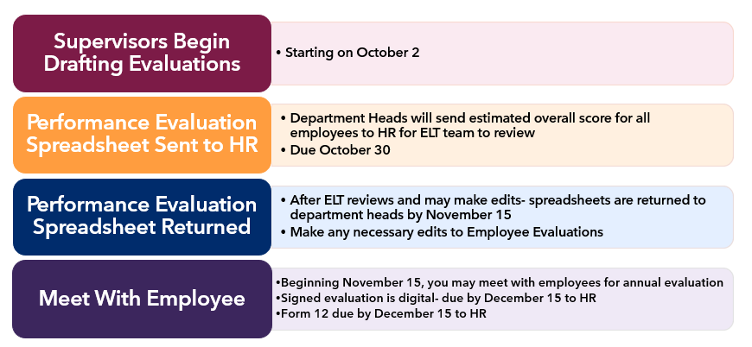

Increases in pay will be performance based for all level pay plans
- Merit Increases will range from 0%-5% maximum
  - 0% Merit Increase for Overall Score of 1
  - 1% Merit Increase for Overall Score of 2
  - 3% Merit Increase for Overall Score of 3
  - 5% Merit Increase for Overall Score of 4

In 2023 (for FY 22) all employees received a Cost of Living Adjustment of 4%. FY 23 evaluations will be the first time all level pay plans will be performance based. For FY 2024 it has been proposed in the budget to give an average merit increase of 3.5% to civilian employees. Given this projection and adhering to the bell curve, increases will range from 0-5% maximum. In FY 22 performance evaluations were guided by bell curve, but not strictly adhered to. This year each department is responsible for adhering to the bell curve for performance-based increases. Pay increases will be effective in January of 2024.

The Bell Curve

Why use the bell curve? The Bell Curve is what’s referred to as normal distribution. Normal distribution is a statistical distribution where the data points are symmetrical around the mean (average) of the dataset. This distribution is often depicted as a bell curve because of its shape, with the majority of the data points clustering around the mean, and the outliers on either side of the curve. The curve is perfectly symmetrical around the mean, while the mean and median are equal. This year we are adhering to the standard 10/80/10 bell curve.

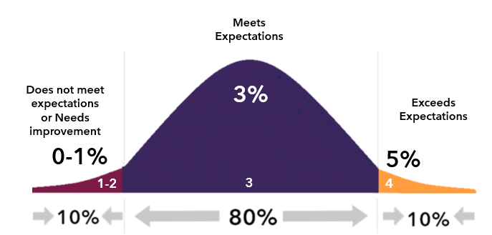

Evaluation Eligibility

All Full Time Civilian Employees and Uniformed Managerial Employees
Must be hired on or before March 31, 2023
Form must be completed by current, immediate supervisor
Review is annual- 1 year only

Evaluation Forms
Additional Sections
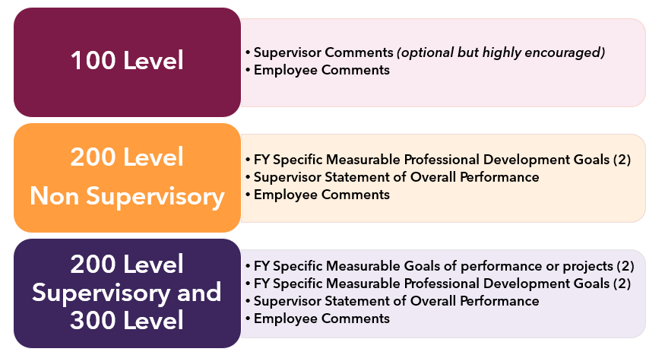

DocuSign Process
All supervisors will be given a DocuSign account. It is the responsibility of each supervisor to initiate the evaluation process.
You must be logged into your DocuSign account. From the Home page you’ll select the yellow start button dropdown- and select ‘Use a Template’.
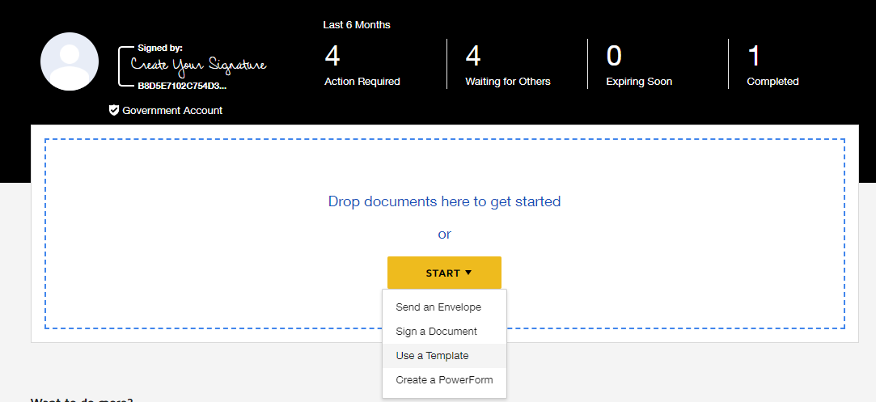

You will be taken to the Select Template Screen. You will have a list of “Shared Folders”. One of which should be named “Learning Institute”. From here you will select which evaluation you want to initiate.
NOTE: There are two different 100 Level Evaluations:
- One is for In Person Signing. This is for the employees that may not have and/or utilize their @cctexas.com e-mail. They will sign the form electronically in person from the supervisor’s electronic device rather than the form going to their e-mail to input employee comments and signature
- One is for digital signature (employee has valid @cctexas.com Email address) and computer access
All 200 and 300 level evaluations are set up be through DocuSign only. An employee does not need to have a DocuSign account in order to sign the evaluation or fill out their comments.

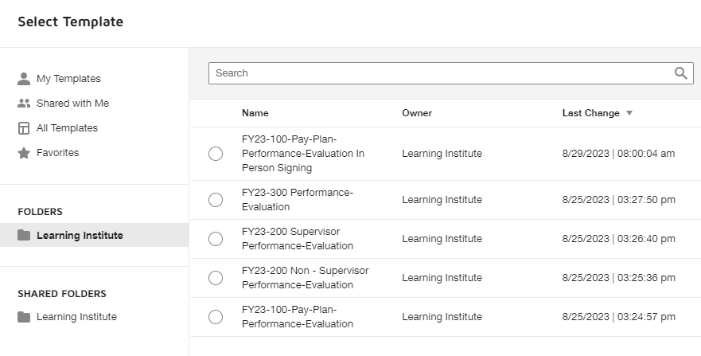

Once you select which form you want to initiate you will select the blue box that says “Add Selected” at the bottom left hand corner.
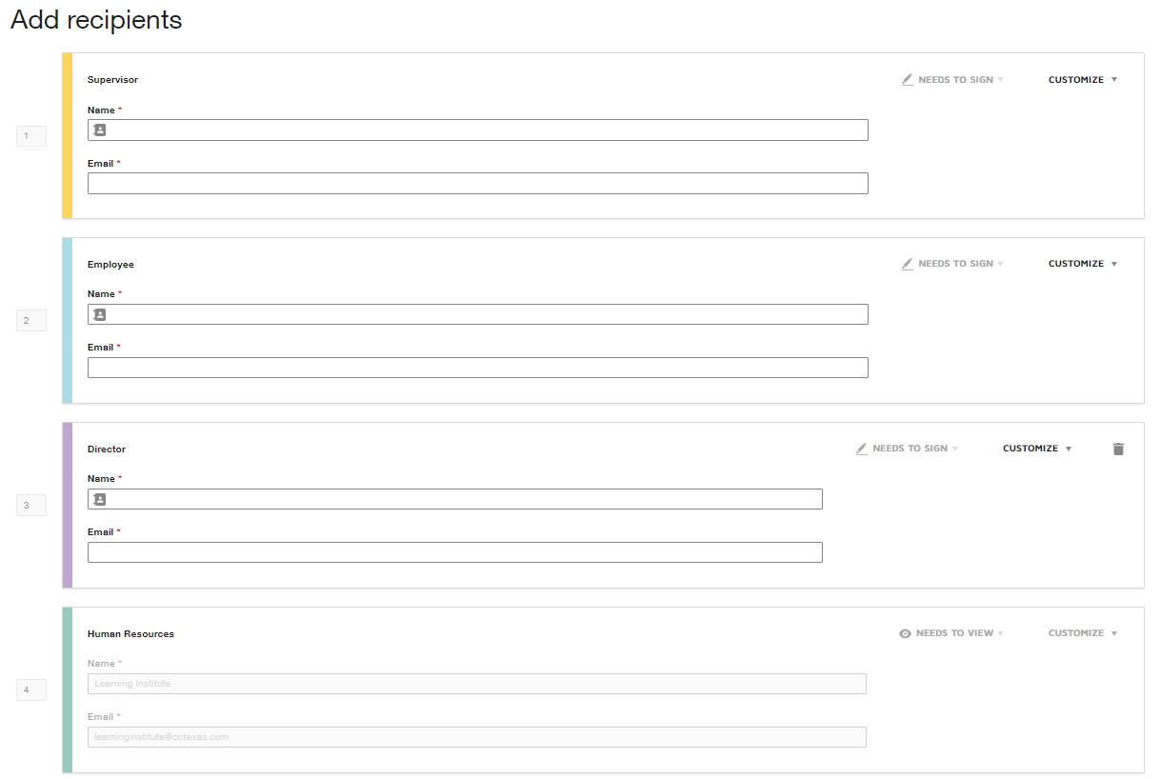
This will now bring you to a screen where you can “Add recipients”. The right hand column will generate a preview of the form. Add recipients is where you will input your name and email, your employee’s name and email and the department director’s name and email.
Please make sure to double check the e-mail address to ensure proper delivery. Once you have completed the fields- you’ll select the send button in the bottom right-hand corner.
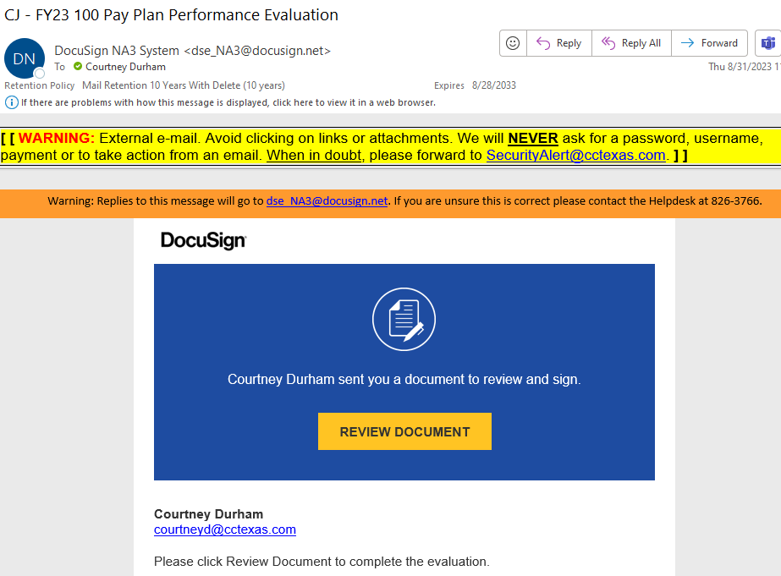
This step is very important as it initiates the evaluation form process. Once you hit “send” you will receive an e-mail from DocuSign. The Subject should say the employee’s name (as you entered it)- which pay plan evaluation was initiated i.e.: Susan Smith -FY23 100 Pay Plan Performance Evaluation. When you are ready to begin your evaluation of the employee you will click on “Review Document”. The e-mail should have came from your name via DocuSign.

When you click on “Review Document” DocuSign should open up in your default web browser. You will select “Continue” to begin filling out the evaluation form. All boxes that are outlined in red are required fields. You will fill out the top of the form with the employee’s name, id number, job title and department. Additionally you will fill out your name, your title, the department director’s name and the date of review. You will then proceed to selecting a 1-4 rating for each category prompt. The average score is automatically formulated to calculate as a whole number only; rounding up/down i.e. an employee can have a score of 3 but not a score of 3.7.
IMPORTANT
If you are drafting the evaluation and not yet ready to have your formal in-person sit down annual evaluation with your employee- DO NOT SIGN. If you sign it- this will automatically route to your employee’s e-mail address and they will be able to review the evaluation. You should not send or review the evaluation with the employee until after November 15th- when the Performance Evaluation Spreadsheets are returned to Department Heads.
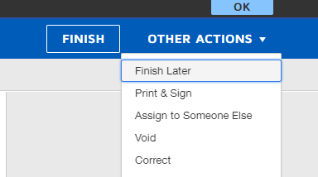
If you want to save your draft select “other actions” and Finish Later. You can access this drafted evaluation you can either click on the original e-mail sent to review document, or you can log into DocuSign and pull it up under “Action Required” on your Home page.

Once you are ready to sign, open the appropriate document. Review in person with your employee. After the in-person you review you can sign the evaluation. Once you Sign in the Supervisor Signature space- click on finish.
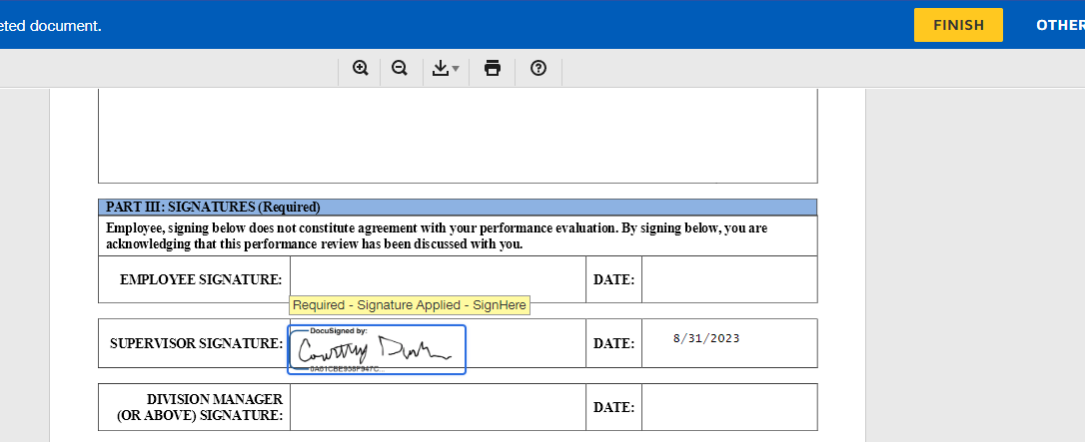
For Digital E-mail Signatures
If this evaluation is going to a 100,200, or 300 level employee who has an e-mail address- after you meet in person and sign, the evaluation will be routed to them for signature via their e-mail. When they receive the signed evaluation from you, the employee can then enter their comments and sign it themselves.
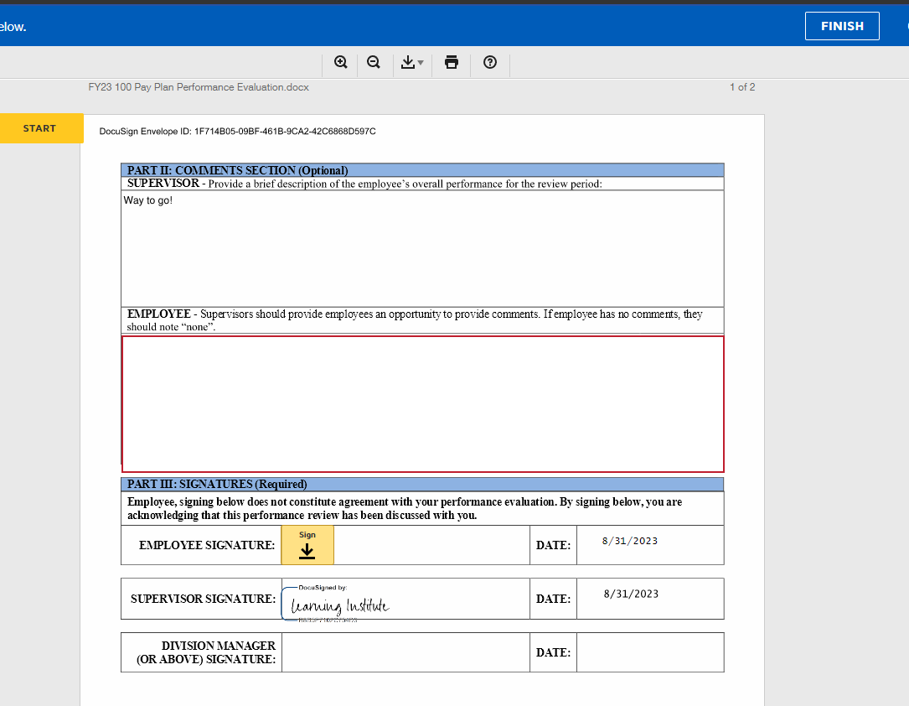
The should fill out any comments they have about their evaluation. If there are none they should type “none”. Once they have signed and clicked finished- the evaluation will then automatically route to the department director (or designee) for their review and signature.
Once the department director or designee has reviewed and signed the employee’s evaluation- it will automatically send to the HR Learning Institute e-mail, where it will be tracked and uploaded to each employee’s personnel file.

For 100 Level- In Person Signers
Make sure for these employees you have selected the FY23- 100-Pay-Plan-Performance Evaluation In Person Signing Template.
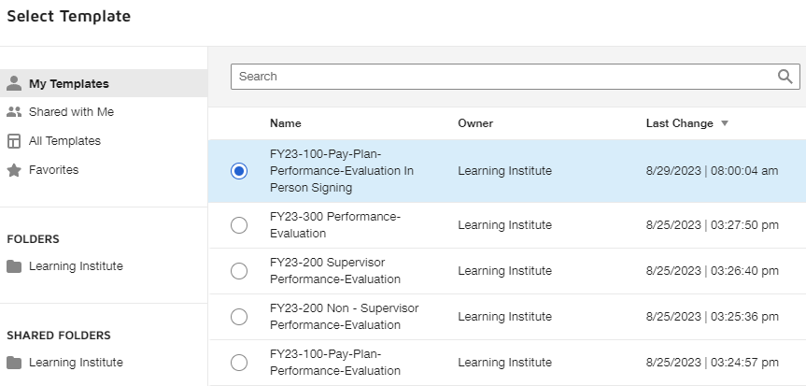
The “Add Recipients” screen will look very similar, however the crucial difference is instead of “Needs to Sign” this template will have “In Person Signer” next to the employees box. You will enter the employee’s name, but under host name and e-mail, you will put your own name and e-mail
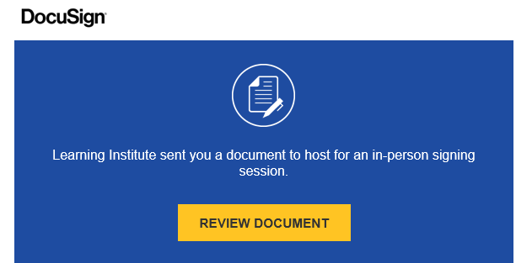
Once you as the supervisor have completed the in-person review and signed it- you should get another e-mail in your inbox for the employee to sign.

After you click on “Review Document”- your web browser will open. You will be routed to a screen that looks like this:
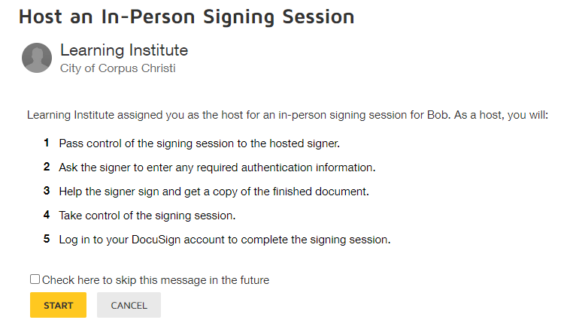

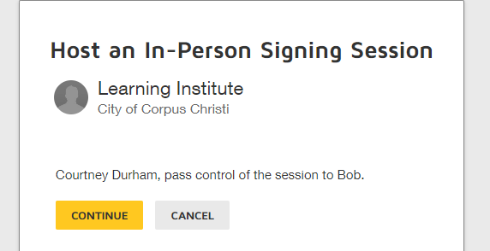
After you click ”start” the page will prompt you to pass control of the session to the employee. At this point, you should ask the employee to utilize your electronic device (most likely computer) to sign. The employee will click “continue”.

The employee will then be taken to the evaluation where they can type in any comments they may have and sign. Like any other signer- the computer can adapt a signature for them, or they can draw a signature with the mouse/trackpad or sign with their finger (tablet).
Once they are finished, they will select the gold “Finish” button. This will trigger a window where the employee can request a copy of the evaluation. You can print them a copy or if they have a personal e-mail address they’d like the signed annual evaluation form sent to- they may enter it. If they want neither- they will select “Continue”. From here the control should be passed back over to the Supervisor.
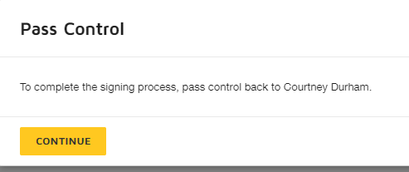

Once the employee has signed and clicked finished- the evaluation will then automatically route to the department director (or designee) for their review and signature.
Once the department director or designee has reviewed and signed the employee’s evaluation- it will automatically send to the HR Learning Institute e-mail, where it will be tracked and uploaded to each employee’s personnel file.
Tracking
You can track the status of any of the evaluations you initiated from your DocuSign home page. The dashboard will let you know how many documents require action (these may be ones you drafted or that need your signature). How many documents you have you are waiting for others to complete (an employee or director signature) and how many have been completed and sent to HR.
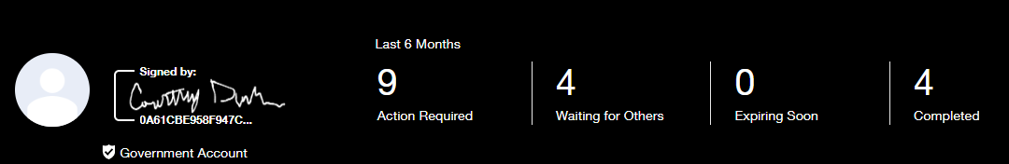

If you have any questions or concerns the Organizational Development team is here to help!
Call 361-826-3336 or e-mail us at LearningInstitute@cctexas.com

